Lesson Notes: DBSCAN (Density-Based Spatial Clustering of Applications with Noise)

Lesson Introduction
Today’s topic is DBSCAN, a powerful unsupervised clustering algorithm that groups data points based on density. Unlike K-Means, it can find arbitrary-shaped clusters and identify outliers/noise automatically.
Mini Agenda:
- Introduction to Density-Based Clustering
- What is DBSCAN
- Key Parameters: Epsilon (ε) & MinPts
- How DBSCAN Works
- Advantages, Limitations & Use Cases
- Practical Example with Dataset
- Business Scenario & Case Study
- Practice Questions & Assignment

Real-World Hook
Imagine a city wants to identify areas of high crime density from police reports. The data is irregularly distributed, and traditional methods like K-Means may fail because they assume spherical clusters.
Problem: Detecting clusters in irregular-shaped spatial data.
Solution: DBSCAN automatically identifies dense regions as clusters and marks isolated points as noise.

https://levelup.gitconnected.com/dbscan-a-density-based-clustering-algorithm-110b726fd6fe
https://clustering-visualizer.web.app/dbscan
https://www.naftaliharris.com/blog/visualizing-k-means-clustering/
https://www.naftaliharris.com/blog/visualizing-dbscan-clustering/

Introduce Topic as a Solution
DBSCAN is a density-based clustering algorithm.
- Groups points that are closely packed together
- Marks points in low-density regions as outliers
- Ideal for spatial data, anomaly detection, and irregularly shaped clusters

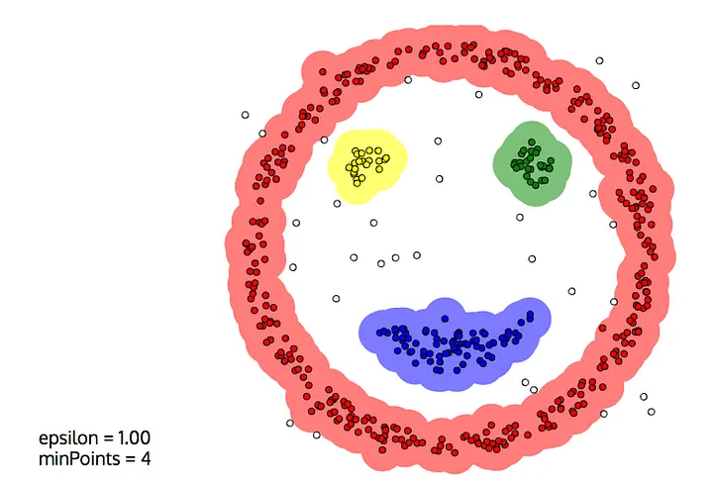

Theory Explanation

What is DBSCAN?
DBSCAN stands for Density-Based Spatial Clustering of Applications with Noise. It identifies clusters based on density rather than distance from a centroid.
Core Concepts:
- Epsilon (ε): Maximum distance between two points to be considered neighbors
- MinPts: Minimum number of points required to form a dense region
- Core Point: Has at least MinPts within ε radius
- Border Point: Lies within ε of a core point but has fewer than MinPts neighbors
- Noise Point: Neither core nor border point
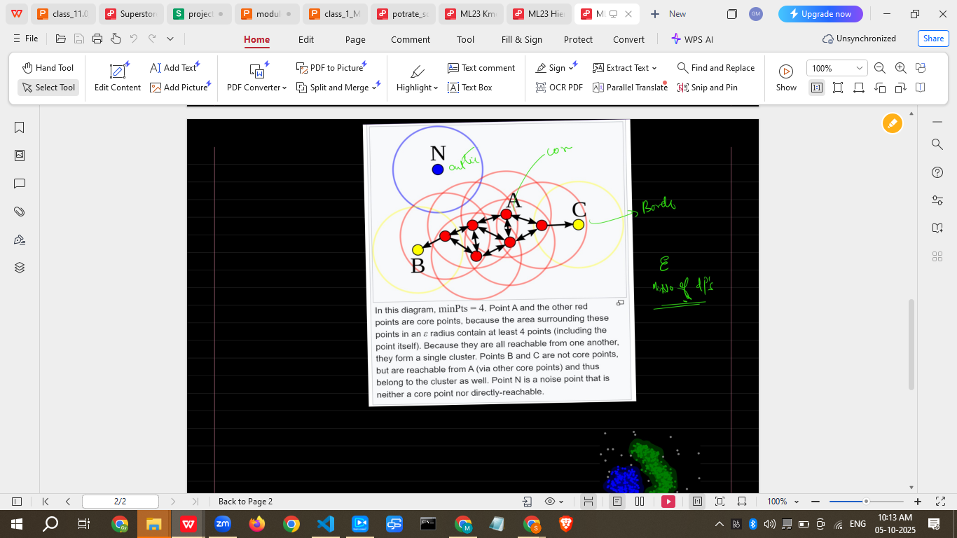
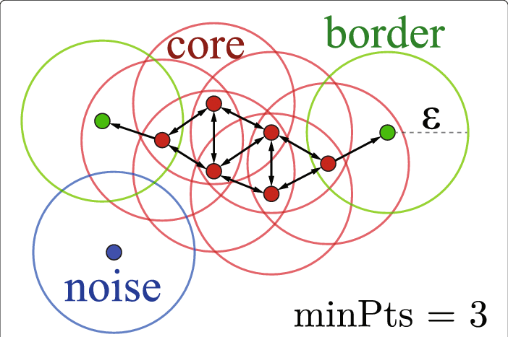

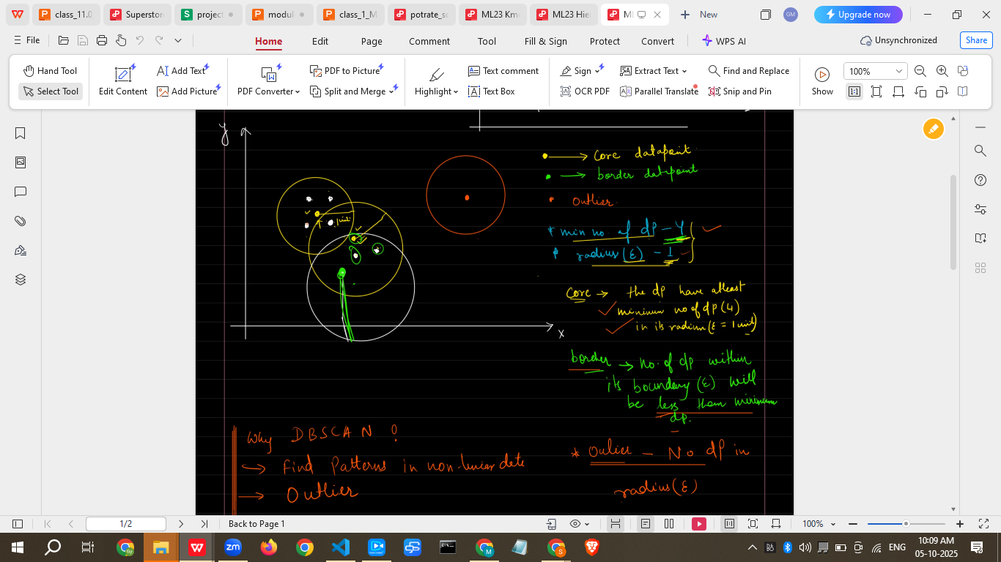

Why Use DBSCAN?
- Detects arbitrary-shaped clusters
- Can identify outliers automatically
- Does not require predefining the number of clusters

When to Use DBSCAN
- Spatial data (GPS, geographic points)
- Datasets with noise/outliers
- Irregular cluster shapes

When NOT to Use
- Very high-dimensional data
- Datasets with widely varying densities

Advantages
- Detects clusters of any shape
- Automatically detects noise
- No need to specify number of clusters

Limitations
- Sensitive to ε and MinPts parameters
- Struggles with clusters of varying densities
- Computationally expensive for very large datasets

Alternatives
- K-Means (spherical clusters)
- Hierarchical Clustering
- OPTICS (similar to DBSCAN but handles varying density)

How DBSCAN Works (Step-by-Step Algorithm)
- Select a random unvisited point P
- Retrieve all points density-reachable from P (within ε radius and MinPts)
- If P is a core point, form a cluster
- Repeat for all points until all points are visited
- Points not assigned to any cluster are labeled noise

Practical Example (Dataset + Exercises)
Sample Dataset (50 points):
X | Y
1 | 2
2 | 2
8 | 7
8 | 8
25 | 80
Python Implementation:
import pandas as pd
import numpy as np
from sklearn.cluster import DBSCAN
import matplotlib.pyplot as plt
from sklearn.preprocessing import StandardScaler

# Sample dataset
data = pd.DataFrame({
'X':[1,2,2,8,8,25,24,25,30,31]*5,
'Y':[2,2,3,7,8,80,79,81,30,31]*5
})

# Scaling
scaler = StandardScaler()
X_scaled = scaler.fit_transform(data)

# DBSCAN Clustering
dbscan = DBSCAN(eps=0.5, min_samples=3)
data['Cluster'] = dbscan.fit_predict(X_scaled)

# Plot clusters
plt.figure(figsize=(8,6))
plt.scatter(data['X'], data['Y'], c=data['Cluster'], cmap='rainbow')
plt.xlabel("X")
plt.ylabel("Y")
plt.title("DBSCAN Clustering")
plt.show()

Business Scenario
Company: Telecom Provider
Problem: Identify high-density areas of network usage
Solution: DBSCAN clusters densely populated regions of activity and identifies outliers where network issues occur. This allows targeted network optimization and resource allocation.

Practice Session (5–10 Questions)
- What does DBSCAN stand for?
- Define core point, border point, and noise point.
- How do ε and MinPts affect clustering?
- Write Python code for DBSCAN on a small dataset.
- Explain a scenario where DBSCAN is better than K-Means.
- What are the limitations of DBSCAN?
- How can you select the optimal ε?
- Give a real-world example of DBSCAN.
- How does scaling affect DBSCAN?
- What happens if clusters have widely varying densities?

Case Study
Mini Project: Spatial Crime Analysis
- Dataset: Crime locations with latitude and longitude
- Apply DBSCAN to identify crime hotspots
- Visualize clusters on a scatter plot
- Identify isolated incidents as noise/outliers
- Provide recommendations to local authorities based on cluster analysis

Assignments
- Generate a synthetic dataset with at least 50 points and apply DBSCAN.
- Experiment with different ε and MinPts values and note the changes in clusters.
- Visualize clusters and identify outliers.
- Compare results with K-Means clustering on the same dataset.

Quiz (3–5 Questions)
- What is the main advantage of DBSCAN over K-Means?
- Define noise points in DBSCAN.
- What are the two main parameters of DBSCAN?
- When should you NOT use DBSCAN?
- Write Python code for DBSCAN on a small 2D dataset.

Recap of Today’s Lesson
- DBSCAN is density-based clustering
- Detects clusters of any shape and identifies outliers
- Key parameters: ε (epsilon) and MinPts
- Best suited for spatial or irregular data
- Alternative to K-Means and Hierarchical Clustering

Streamlit Interactive Application
- Users can upload datasets, experiment with ε and MinPts, visualize clusters interactively, and identify noise points.
- Makes learning hands-on and practical.

Resource Links
- Scikit-learn DBSCAN Documentation
- DBSCAN Tutorial by Machine Learning Plus
- DBSCAN Explained with Examples

Common Interview Questions
- Explain DBSCAN in simple terms.
- What are core, border, and noise points?
- How do you choose ε and MinPts?
- Give an example where DBSCAN is better than K-Means.
- Limitations of DBSCAN and how to overcome them.
- How does DBSCAN handle outliers?
- Difference between DBSCAN and K-Means.
- Python code implementation for DBSCAN.
- What happens with clusters of varying densities?
- How to visualize DBSCAN clusters?

I can now build a Streamlit app for DBSCAN where learners can upload datasets, set ε and MinPts interactively, visualize clusters, and see outliers marked, making it a hands-on project for learning DBSCAN.
Do you want me to create that app next?

